SECTION A
Screenshot showing git init and git config output.
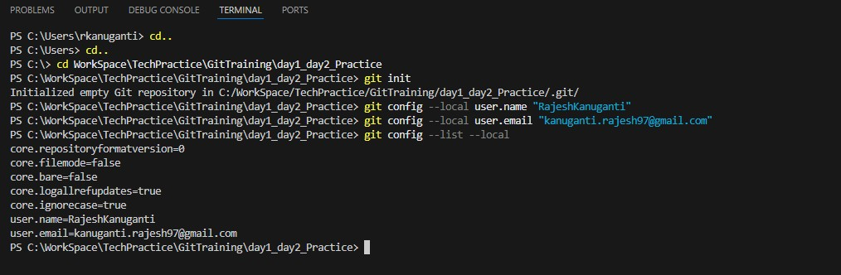
SECTION B
why the second edit to intro.txt didn’t go into the commit.
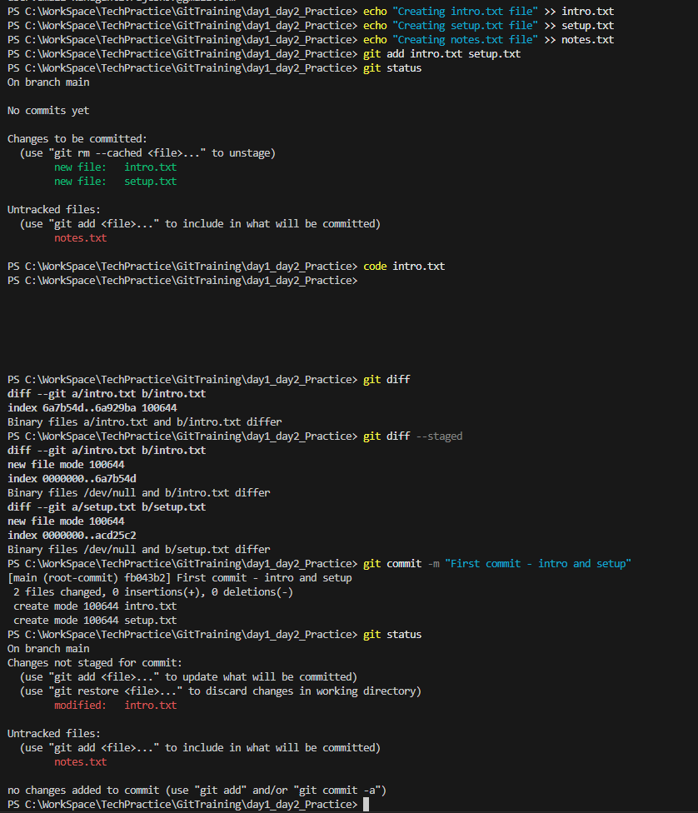

The second edit to intro.txt didn’t go into the commit because it was not staged after the edit. Git only includes changes that are staged at the time of the commit. Since the file was modified again but not re-added, those changes remained in the working directory and were excluded from the commit.

SECTION C
ls -a : Getting Error
git log --oneline
git show HEAD
git cat-file -p HEAD
git cat-file -p HEAD^{tree} Getting Error

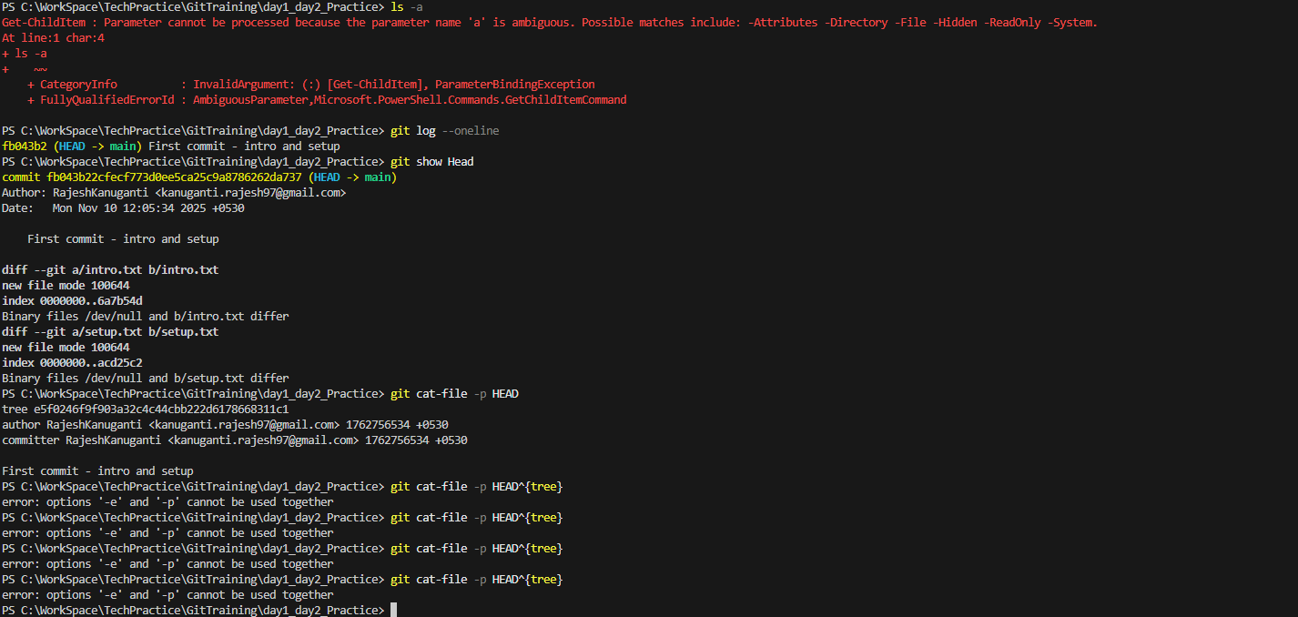
what are blob, tree, and commit object?
- A blob is just the content of a file. Git stores the file’s data, but not its name or location.
- A tree is like a folder. It keeps track of file names, their types (like blob or another tree), and how they’re organized.
- A commit is a snapshot of your project at a point in time. It links to a tree and includes a message, author info, and history.
Part 2:

1. What happens inside Git when you run git add file.txt?
- Git moves the current state of file.txt from the Working Directory to the Staging Area.
- It calculates a SHA-1 hash of the file’s contents and stores it as a blob object in the .git/objects directory.
- The staging area (also called the index) is updated to include this blob, preparing it for the next commit.

2. Why do we say a commit is a snapshot, not a diff?
- Each commit in Git stores a complete snapshot of all files that are tracked, not just the changes.
- Internally, Git optimizes storage by reusing unchanged blobs, but conceptually, each commit represents the full state of the project at that point in time.

3. What is stored inside the .git folder?
The .git folder is the heart of a Git repository. It contains:
- HEAD: points to the current branch reference.
- objects/: stores all content (blobs, trees, commits) as hashed objects.
- refs/: contains pointers to branches and tags.
- index: the staging area.
- config: repository-specific configuration.
- logs/: history of changes to references.

4. What does HEAD point to, and how is it updated?
- HEAD points to the current branch reference, e.g., refs/heads/main.
- When you commit, Git updates the branch reference to point to the new commit, and HEAD follows it.
- You can also detach HEAD to point directly to a commit (e.g., during a checkout of a specific commit).

5. What’s the difference between the Working Directory and the Staging Area?
- Working Directory: Your actual project files on disk.
- Staging Area (Index): A snapshot of files that you want to include in the next commit.
- Changes in the working directory are not tracked until staged.

6. What happens if you change a file after staging it?
- The staged version remains unchanged.
- The working directory now has a modified version.
- Running git status will show the file as modified, even though it’s already staged.
- You can re-stage it with git add to update the staged version.

7. Why doesn’t Git store whole files for every commit?
- Git uses content-addressable storage and stores files as blobs identified by their SHA-1 hash.
- If a file hasn’t changed, Git reuses the existing blob.
- This makes Git efficient in both storage and performance.

8. What is version control, and how does Git make it easier?
- Version control tracks changes to files over time, allowing collaboration, rollback, and branching.
- Git makes it easier by:
  - Being distributed (every clone is a full repo).
  - Supporting branching and merging efficiently.
  - Storing data securely and compactly.
  - Providing powerful tools like diff, log, revert, and stash.

9. What are tracked vs untracked files?
- Tracked files: Files that Git is monitoring (added and committed).
- Untracked files: Files in the working directory that haven’t been staged or committed.
- git status shows both.
10. Complete flow of commands from creating a repo to committing your first file:
# Step 1: Create a new directory with name day1_day2_practice
mkdir day1_day2_practice

#Step 2: Change Directory to the folder named day1_day2_practice
cd day1_day2_practice

#Step 3: Intialize the Git
git init

# Step 4: Create a file
echo "Hello, Git!" > file.txt

# Step 5: Check status
git status

# Step 6: Stage the file
git add file.txt

# Step 7: Commit the file
git commit -m "Initial commit with file.txt"

# Step 8: Check log
git log

